

G Motors India EV-SALES

SQL ANALYTIC REPORT



FROM

ADITYA BORKAR

1. List the top 3 and bottom 3 makers for the fiscal years 2023 and 2024 in terms of the number of 2-wheelers sold.

#top

select maker , sum(electric_vehicles_sold) as TotalSold

from dim_date inner join electric_vehicle_sales_by_makers on dim_date.ï»¿date = electric_vehicle_sales_by_makers.ï»¿date

WHERE vehicle_category = '2-Wheelers'

AND fiscal_year IN (2023 ,2024)

GROUP BY maker

ORDER BY TotalSold DESC limit 3;

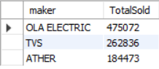

#BOTTOM

select maker , sum(electric_vehicles_sold) as TotalSold

from dim_date inner join electric_vehicle_sales_by_makers on dim_date.ï»¿date = electric_vehicle_sales_by_makers.ï»¿date

WHERE vehicle_category = '2-Wheelers'

AND fiscal_year IN(2023,2024)

GROUP BY maker

ORDER BY TotalSold asc limit 3;

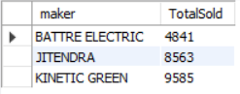

1. Find the overall penetration rate in India

SELECT (sum(electric_vehicles_sold) /

sum(total_vehicles_sold)) * 100 AS penetration_rate

FROM electric_vehicle_sales_by_state ;



1. Identify the top 5 states with the highest penetration rate in 2-wheeler and 4-wheeler EV sales in FY 2024.

select state,

sum(electric_vehicles_sold)/

sum(total_vehicles_sold) * 100 as penetration_rate

from `dim_date` inner join `electric_vehicle_sales_by_state` on dim_date.ï»¿date = electric_vehicle_sales_by_state.ï»¿date

where fiscal_year = 2024

group by state

order by penetration_rate desc limit 5 ;

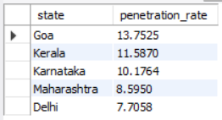

1. List the top 5 states having highest number of EVs sold in 2023

SELECT YEAR(ï»¿date) AS fiscal_year,state,SUM(total_vehicles_sold) AS total_sold

FROM electric_vehicle_sales_by_state

WHERE YEAR(ï»¿date) = 2023

GROUP BY fiscal_year, state

ORDER BY total_sold DESC

LIMIT 5;

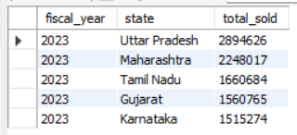

1. Which are the Top 5 EV makers in India?

select maker , sum(electric_vehicles_sold)

from `electric_vehicle_sales_by_makers`

group by maker

order by sum(electric_vehicles_sold) desc

limit 5 ;

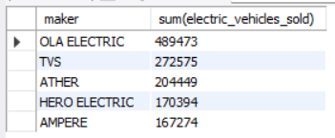

1. How many EV makers sell 4-wheelers in India?

select count(distinct maker)

from `electric_vehicle_sales_by_makers`

where vehicle_category = '4-Wheelers';

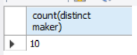

1. What is ratio of 2-wheeler makers to 4-wheeler makers?

SELECT

(select count(distinct maker)from `electric_vehicle_sales_by_makers` where vehicle_category = '2-Wheelers')/

(select count(distinct maker)from `electric_vehicle_sales_by_makers` where vehicle_category = '4-Wheelers')

as ratio ;

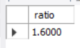

1. What are the quarterly trends based on sales volume for the top 5 EV makers (4-wheelers) from 2022 to 2024?

WITH top5M AS (

SELECT maker

FROM dim_date

INNER JOIN electric_vehicle_sales_by_makers

ON dim_date.ï»¿date = electric_vehicle_sales_by_makers.ï»¿date

WHERE vehicle_category = '4-Wheelers' AND fiscal_year BETWEEN 2022 AND 2024

GROUP BY maker

ORDER BY SUM(electric_vehicles_sold) DESC

LIMIT 5 )

SELECT fiscal_year, quarter, top5M.maker,

SUM(electric_vehicles_sold) AS sales_volume

FROM dim_date

INNER JOIN electric_vehicle_sales_by_makers

ON dim_date.ï»¿date = electric_vehicle_sales_by_makers.ï»¿date

join Top5M on electric_vehicle_sales_by_makers.maker = Top5M.maker

WHERE vehicle_category = '4-Wheelers'

AND fiscal_year BETWEEN 2022 AND 2024

GROUP BY fiscal_year, top5M.maker, quarter

ORDER BY fiscal_year, quarter, sales_volume DESC;

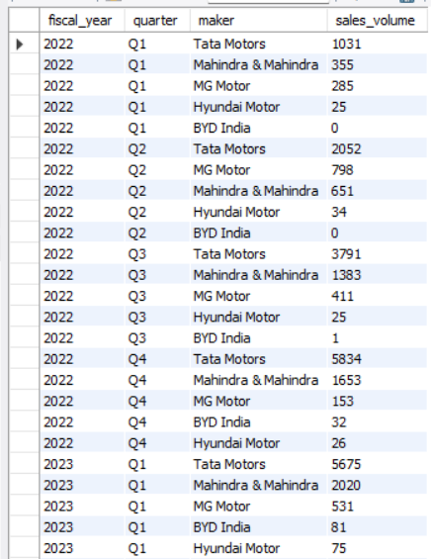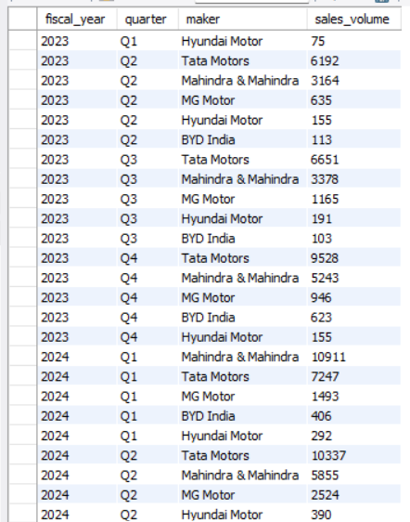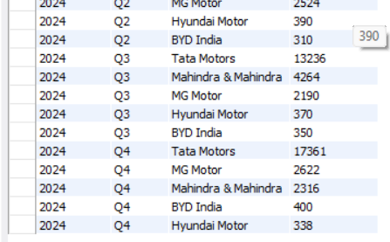

1. How do the EV sales and penetration rates in Maharashtra compare to Tamil Nadu for 2024?

select state,sum(electric_vehicles_sold) as EV_SALES,

sum(electric_vehicles_sold)/

sum(total_vehicles_sold) * 100 as penetration_rate

from `dim_date` inner join `electric_vehicle_sales_by_state` on dim_date.ï»¿date = electric_vehicle_sales_by_state.ï»¿date

where state in ('Maharashtra' , 'Tamil Nadu')

and fiscal_year = 2024

group by state ;

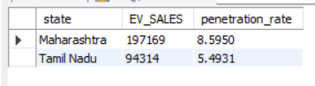

1. What are the peak and low season months for EV sales based on the data from 2022 to 2024?

#peak season months

select month(ï»¿date) ,sum(electric_vehicles_sold)

from `electric_vehicle_sales_by_makers`

where year(ï»¿date) between 2022 and 2024

group by month(ï»¿date)

order by sum(electric_vehicles_sold) desc ;

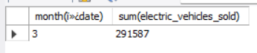

#low season months

select month(ï»¿date) ,sum(electric_vehicles_sold)

from `electric_vehicle_sales_by_makers`

where year(ï»¿date) between 2022 and 2024

group by month(ï»¿date)

order by sum(electric_vehicles_sold) asc ;

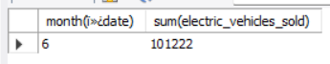

1. Estimate the revenue growth rate of 4-wheeler and 2-wheelers EVs in India for 2022 vs 2024 and 2023 vs 2024, assuming an average unit price.

# 2-Wheelers

with revenue_per_year AS (

SELECT vehicle_category, fiscal_year,

SUM(electric_vehicles_sold *85000 ) AS total_revenue

FROM electric_vehicle_sales_by_makers

JOIN dim_date ON electric_vehicle_sales_by_makers.ï»¿date = dim_date.ï»¿date

where vehicle_category = '2-Wheelers'

GROUP BY vehicle_category, fiscal_year),

pivot_revenue AS (

SELECT

MAX(CASE WHEN fiscal_year = 2022 THEN total_revenue ELSE 0 END) AS revenue_2022,

MAX(CASE WHEN fiscal_year = 2023 THEN total_revenue ELSE 0 END) AS revenue_2023,

MAX(CASE WHEN fiscal_year = 2024 THEN total_revenue ELSE 0 END) AS revenue_2024

FROM revenue_per_year)

SELECT

((revenue_2024 - revenue_2022) / revenue_2022) * 100 AS growth_rate_2022_vs_2024,

((revenue_2024 - revenue_2023) / revenue_2023) * 100 AS growth_rate_2023_vs_2024

FROM pivot_revenue ;



# 4-WHEELERS

with revenue_per_year AS (

SELECT vehicle_category, fiscal_year,

SUM(electric_vehicles_sold *1500000 ) AS total_revenue

FROM electric_vehicle_sales_by_makers

JOIN dim_date ON electric_vehicle_sales_by_makers.ï»¿date = dim_date.ï»¿date

where vehicle_category = '4-Wheelers'

GROUP BY vehicle_category, fiscal_year),

pivot_revenue AS (

SELECT

MAX(CASE WHEN fiscal_year = 2022 THEN total_revenue ELSE 0 END) AS revenue_2022,

MAX(CASE WHEN fiscal_year = 2023 THEN total_revenue ELSE 0 END) AS revenue_2023,

MAX(CASE WHEN fiscal_year = 2024 THEN total_revenue ELSE 0 END) AS revenue_2024

FROM revenue_per_year)

SELECT

((revenue_2024 - revenue_2022) / revenue_2022) * 100 AS growth_rate_2022_vs_2024,

((revenue_2024 - revenue_2023) / revenue_2023) * 100 AS growth_rate_2023_vs_2024

FROM pivot_revenue ;

